Pertussis Transmission Model
System Description and Validation Reference

Age-structured, stochastic SEIRS model with a parallel partial-immunity track
EpyScenario platform (EpiStorm / ISI Foundation) — pertussis extension by SOAR International Responder Systems
Version 1.0 · August 2026 · CDC CFA Insight Net
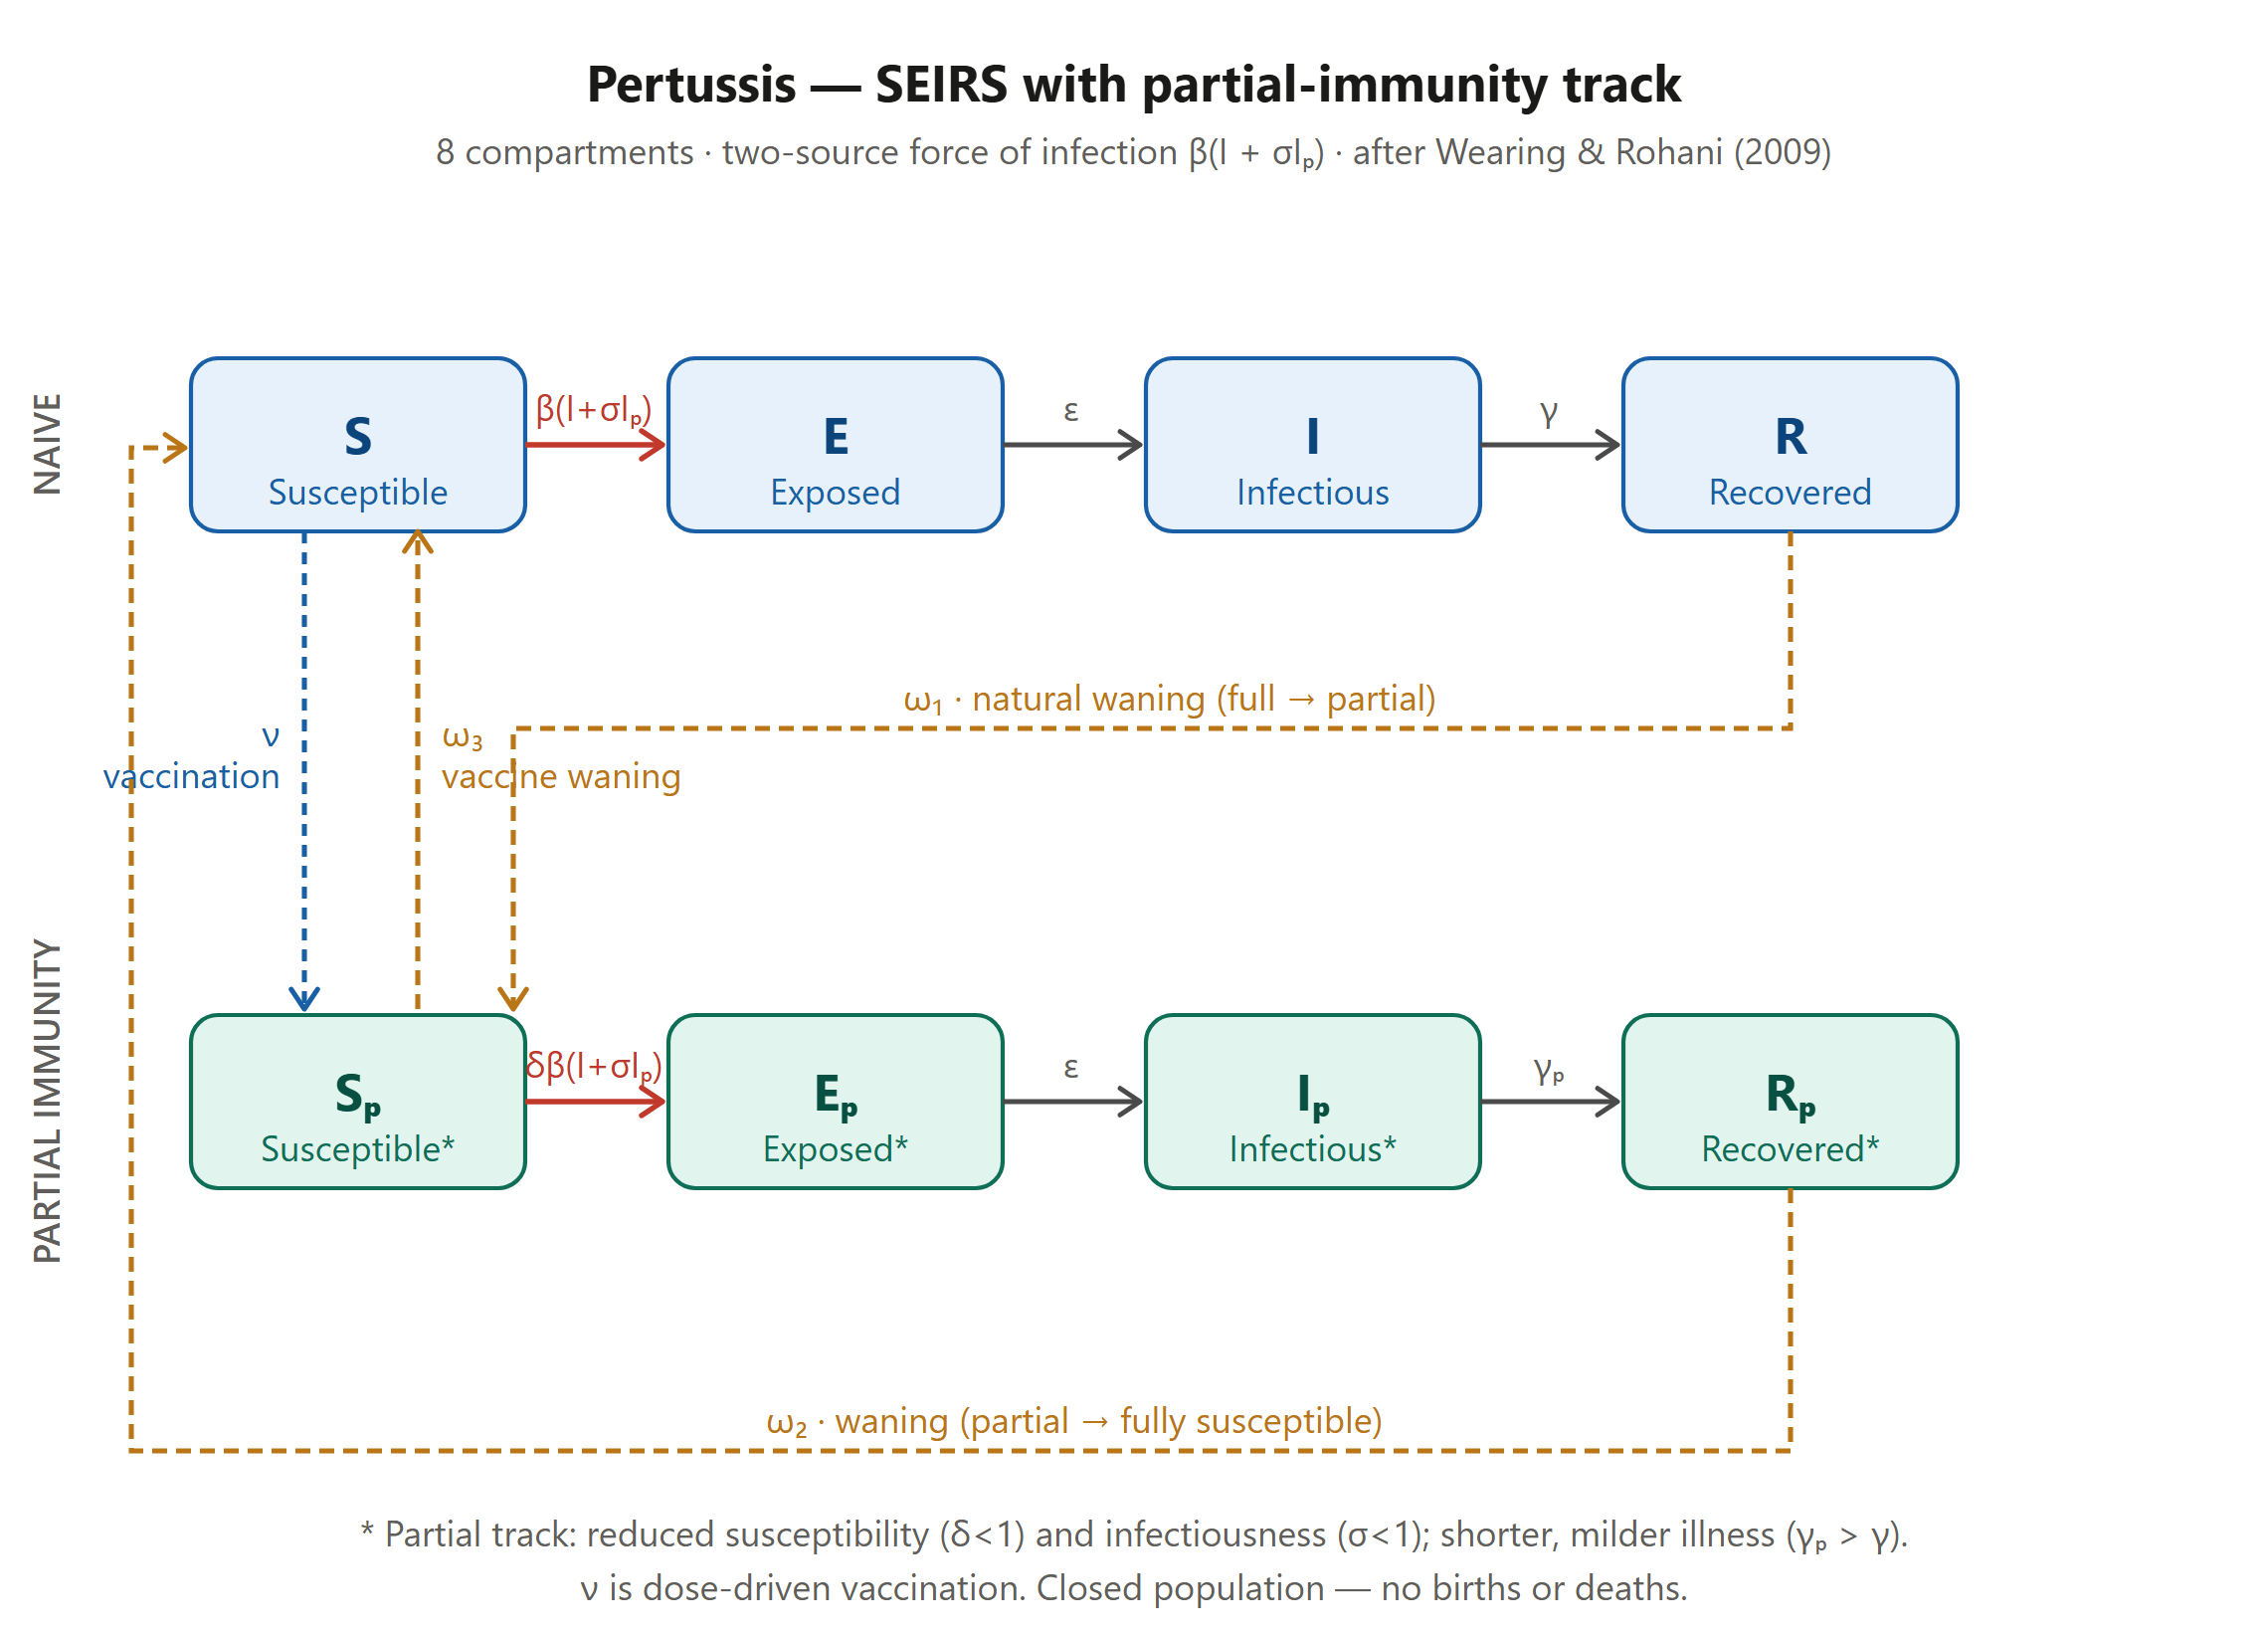
Figure 1. Compartmental structure. Naive track (blue) S→E→I→R and partially-immune track (teal) Sₚ→Eₚ→Iₚ→Rₚ. Red arrows are the two-source force of infection; amber dashed arrows are waning (ω₁, ω₂, ω₃); the blue dashed arrow is dose-driven vaccination (ν).

1. Purpose and scope
This document specifies the pertussis (whooping cough) transmission model implemented in the EpyScenario dashboard. It is written for an epidemiologist or modeller who will interpret, parameterise, and validate the model — not as a user guide to the interface. It defines the compartmental structure, the governing equations, the force of infection and age-structured contact model, the parameterisation and its epidemiological basis, the representation of vaccination and waning immunity, the stochastic simulation and its outputs, and the intended calibration and validation workflow, followed by an explicit statement of assumptions and limitations.
The model was developed as a decision-support proof of concept for recurrent pertussis surges in Lane County, Oregon, and is intended to be calibrated against local case data. It extends the epydemix modelling framework and the EpyScenario dashboard with a pertussis-specific compartmental structure and a calibration workflow.

2. Epidemiological rationale for the model structure
Pertussis has several features that a simple SEIR or SEIRS model cannot represent and that together motivate the two-track structure used here:
- High transmissibility. The basic reproduction number is among the highest of vaccine-preventable diseases (commonly cited R₀ ≈ 12–17), so susceptibility must be tightly controlled by immunity to avoid unrealistic explosive dynamics.
- Waning immunity. Both infection-derived and vaccine-derived protection decay over years, so recovered and vaccinated individuals re-enter the susceptible pool. Pertussis is therefore endemic with multi-year cycles rather than a single epidemic.
- Partial (attenuated) reinfection. Previously exposed or vaccinated individuals who are reinfected tend to have milder, shorter illness and are less infectious. These partially-immune infections are frequently undiagnosed and constitute a 'silent reservoir' that sustains transmission even in highly vaccinated populations — the central reason pertussis persists despite high coverage.
- Latent period. A 7–10 day incubation before infectiousness requires an exposed (E) compartment.
- Vaccination as partial protection. A large fraction of the population begins with vaccine-derived partial immunity rather than full sterilising immunity.
The structure follows the partial-immunity formulation of Wearing & Rohani (2009), in which a naive track (fully susceptible individuals experiencing classic disease) runs in parallel with a partial-immunity track (reduced susceptibility, milder and less infectious disease). This captures the adolescent/adult reservoir that drives resurgence and transmission to under-vaccinated infants.

3. Model structure
The model is an age-structured, stochastic, eight-compartment SEIRS model with a parallel partial-immunity track (Figure 1). The naive track S→E→I→R describes individuals with no prior immunity experiencing full disease. The partial track Sₚ→Eₚ→Iₚ→Rₚ describes individuals with vaccine-derived or waned immunity: they are infected at reduced rate (susceptibility factor δ<1), experience shorter illness (faster recovery γₚ>γ), and transmit less (infectiousness factor σ<1). The two tracks are coupled by a shared force of infection and by cross-links representing vaccination and waning immunity. The population is closed (no births or deaths).

4. Compartment definitions
Symbol | Compartment | Description
S | Susceptible (naive) | No prior immunity; fully susceptible; classic disease if infected.
E | Exposed (naive) | Infected, latent, not yet infectious (mean latent period 1/ε).
I | Infectious (naive) | Fully infectious, classic paroxysmal pertussis; principal transmitter.
R | Recovered (naive) | Strong but temporary post-infection immunity.
Sₚ | Susceptible (partial) | Vaccine-derived or waned partial immunity; reduced susceptibility δ.
Eₚ | Exposed (partial) | Reinfected partially-immune individual in the latent phase.
Iₚ | Infectious (partial) | Milder, shorter, less infectious illness (σ); the undiagnosed reservoir.
Rₚ | Recovered (partial) | Recovered from reinfection; residual immunity that wanes further.
N = S+E+I+R+Sₚ+Eₚ+Iₚ+Rₚ is conserved. Each of the five age bands (0–4, 5–19, 20–49, 50–64, 65+) carries its own copy of the eight compartments; the bands are coupled through the age-structured contact matrix in the force of infection.

5. Transitions and flows
From → To | Rate | Interpretation
S → E | λ | Naive infection (force of infection).
Sₚ → Eₚ | δ·λ | Partial-track infection at reduced susceptibility.
E → I ; Eₚ → Iₚ | ε | Progression from latent to infectious (incubation).
I → R | γ | Recovery of naive infection.
Iₚ → Rₚ | γₚ | Faster recovery of milder partial infection (γₚ>γ).
R → Sₚ | ω₁ | Waning of full immunity to partial (natural).
Rₚ → S | ω₂ | Waning of residual partial immunity to fully susceptible.
Sₚ → S | ω₃ | Waning of vaccine-derived protection to fully susceptible.
S → Sₚ | ν(t) | Vaccination (dose-driven), moves susceptibles to partial immunity.
Note on ω₃. Without vaccine waning, a vaccinated individual placed in Sₚ that never becomes infected would remain at reduced susceptibility indefinitely (Sₚ's only other exit is infection). ω₃ (Sₚ→S) represents the documented decay of DTaP-derived protection over roughly 5–10 years — the mechanism behind adolescent resurgence and the rationale for the 11-year Tdap booster. ω₁ and ω₂ are post-infection waning and do not cover vaccine-derived decay.

6. Governing equations
For a single age band (the age index i is suppressed for clarity; each band has its own copy of these equations, coupled through λ), the deterministic mean-field dynamics are:
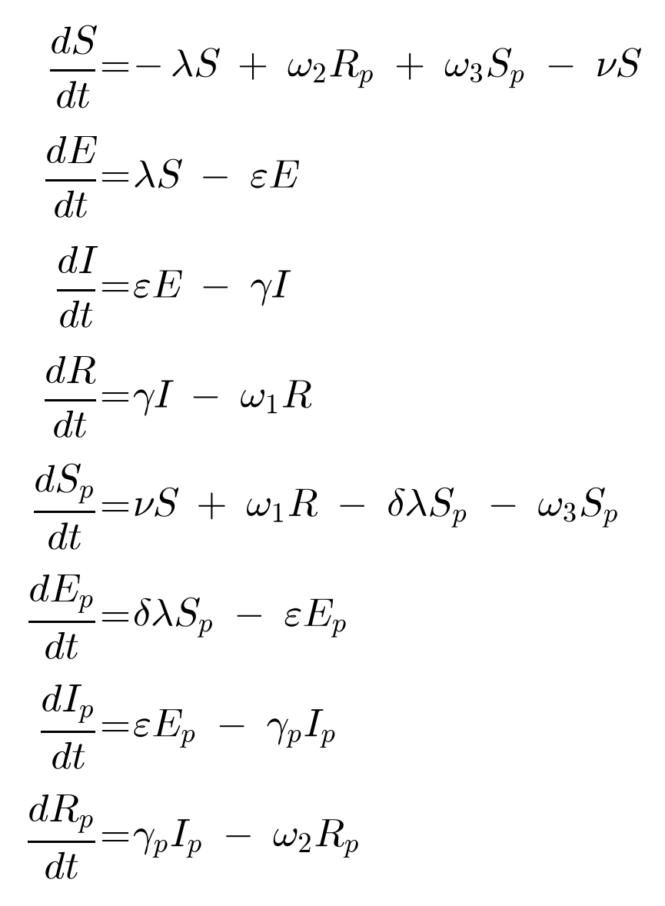
Governing ordinary differential equations for one age band. The right-hand sides sum to zero, so the population is conserved (closed system).
The dashboard integrates the stochastic analogue of this system (per age band) rather than the deterministic ODEs: transitions are realised as discrete stochastic events using the epydemix engine, and an ensemble of Nsim independent replicates is run. Reported trajectories are ensemble quantiles (median and, where shown, credible bands).

7. Force of infection and age-structured mixing
Transmission is frequency-dependent and driven by both infectious compartments — the naive I and the partial Iₚ, the latter weighted by its reduced infectiousness σ. The force of infection on age band i is:
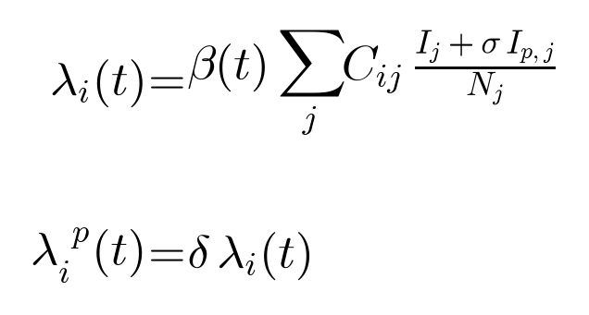
Force of infection. λ acts on naive susceptibles S; partial susceptibles Sₚ experience δ·λ. C_ij is the mean number of contacts a person in band i has with band j.
The contact matrix C is the sum of four setting-specific age-by-age matrices — home, school, work, and community — obtained for the selected geography from the epydemix-data synthetic contact matrices. This encodes age-appropriate mixing: school-age bands dominate the school layer, working ages dominate the work layer, and the youngest and oldest make essentially no workplace contacts. Non-pharmaceutical interventions act by reducing one or more layers over a date window.
The transmission rate is scaled so that the user-specified basic reproduction number is recovered on the naive track, using the dominant eigenvalue (spectral radius) ρ(C) of the summed contact matrix, and is optionally modulated seasonally:
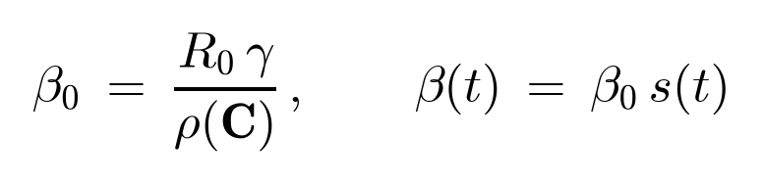
R₀ is defined on the naive track. β₀ is calibrated from R₀, the naive recovery rate γ, and ρ(C); s(t) is a seasonal modulation factor (weak for pertussis, peaking in late summer/autumn).

8. Parameters
Default values and plausible ranges below reflect the pertussis literature (principally Wearing & Rohani, 2009; Lavine et al., 2011; CDC) and are user-adjustable. R₀ is defined on the naive track.
Symbol | Meaning | Default | Plausible range | Basis
R₀ | Basic reproduction number (naive) | 12 | 8–17 | Classic pertussis; Wearing & Rohani
1/ε | Latent (incubation) period | 9 d | 7–10 d | CDC incubation 7–10 d
1/γ | Infectious period (naive, I) | 21 d | 14–28 d | Communicability of untreated disease
1/γₚ | Infectious period (partial, Iₚ) | 10 d | 7–14 d | Shorter, milder in partially immune
σ | Relative infectiousness of Iₚ | 0.20 | 0.1–0.3 | Reduced onward transmission
δ | Relative susceptibility of Sₚ | 0.30 | 0.1–0.5 | Residual protection
1/ω₁ | Waning: full→partial (R→Sₚ) | 4 y | 3–5 y | Loss of sterilising immunity
1/ω₂ | Waning: partial→susceptible (Rₚ→S) | 15 y | 10–20 y | Slow loss of residual protection
1/ω₃ | Vaccine waning (Sₚ→S) | 10 y | 5–10 y | DTaP protection decay; Tdap rationale
ν(t) | Vaccination rate (dose-driven) | schedule | — | DTaP/Tdap coverage by age band
s(t) | Seasonality (peak day; amplitude) | day 240; Low | — | Weak late-summer/autumn seasonality
Implementation note. In the source code the incubation rate ε is named 'gamma' (1/incubation_period) and the naive recovery rate γ is named 'mu' (1/infectious_period); the partial recovery rate γₚ is 'mu_p'. This document uses standard epidemiological notation (ε for incubation, γ/γₚ for recovery) — a validator reading the code should apply this mapping.

9. Vaccination and waning immunity
Vaccination moves fully-susceptible individuals directly into the partially-immune pool (S→Sₚ): the model treats immunisation as conferring partial (non-sterilising) protection with reduced susceptibility δ, consistent with acellular pertussis vaccine performance. Vaccination is dose-driven: campaigns specify a target coverage, efficacy, timing and age band, which are converted to a per-day, per-band dose schedule ν(t).
The CDC DTaP/Tdap schedule is provided as a preset. Because the model has no birth cohorts or aging, the per-individual dose calendar (2/4/6/15–18 months, 4–6 years, 11 years, then decennial) cannot be represented as dated milestones; each schedule element is instead expressed as program-level coverage of the relevant age band over the simulation window. Vaccine-derived protection subsequently decays through ω₃ (Sₚ→S); natural post-infection immunity decays through ω₁ (R→Sₚ) and then ω₂ (Rₚ→S).

10. Initial conditions and immunity seeding
A simulation starts from an endemic-like immune landscape. Two coarse controls — initial infected fraction and background immunity fraction — are distributed across the eight compartments: initial infections are split between the naive (E/I) and partial (Eₚ/Iₚ) tracks, and the immune pool is distributed across Sₚ, Rₚ and R (most vaccinated individuals sit in Sₚ). For calibration, immunity can instead be specified per age band using a saved coverage profile (e.g. derived from local vaccination-status data), overriding the uniform background-immunity control so that the starting susceptibility landscape matches observation.

11. Contact interventions
Non-pharmaceutical interventions are represented as time-bounded reductions of one contact layer (home, school, work, or community) or all layers. During an intervention window the corresponding age-by-age contact matrix is scaled by a reduction factor, lowering the relevant entries of C and hence the force of infection. Because layers are age-specific, a school closure principally reduces mixing among school-age bands, whereas workplace measures principally affect working ages.

12. Stochastic simulation and outputs
Each scenario is run as an ensemble of Nsim independent stochastic replicates with a fixed integration time step dt over a user-specified horizon. The engine returns, per age band and overall: compartment time series (prevalence of S, E, I, R, Sₚ, Eₚ, Iₚ, Rₚ) and transition time series (incidence flows such as E→I and Eₚ→Iₚ). Summary metrics include the epidemic peak (prevalence and timing), the final attack rate, cumulative infections, and — for pertussis specifically — the vaccinated (partial-track) share of cases, computed as Eₚ→Iₚ incidence divided by total (E→I + Eₚ→Iₚ) incidence.

13. Calibration and validation

13.1 Data provenance (Lane County)
The observed dataset used for calibration is a case cross-tabulation by age and vaccination-up-to-date status (No / Unknown / Yes; 489 cases in total — 160 No, 18 Unknown, 311 Yes) for Lane County, Oregon. Its stated source is the Lane County pertussis case line-list, provided by the SOAR/IRS team; the counts were transcribed verbatim into the model and are now maintained as an editable CSV (data/observed/lane_county_pertussis.csv), loaded at start-up by data/observed_datasets.py via load_raw_from_csv(); the in-code LANE_COUNTY_RAW table is retained only as a fallback. A CSV carries a small metadata header (name, geography_hint, note, source), so additional counties or seasons can be added by dropping further CSV files into data/observed/ without code changes. Single-year ages 1–21 and the older age bands are aggregated to the five model age bands; 65+ is folded into the source’s combined “50+” category. The exact surveillance source, case definition, and collection period are attributable to the providing system and are not independently verified in this model.
Model band | No (naive) | Unknown | Yes (partial) | Total
0–4 (ages 1–4) | 40 | 0 | 33 | 73
5–19 | 87 | 7 | 220 | 314
20–49 | 24 | 10 | 50 | 84
50–64 (“50+”) | 9 | 1 | 8 | 18
65+ | 0 | 0 | 0 | 0
Vaccination status maps to the model tracks: not up to date → naive (I / E→I), up to date → partial (Iₚ / Eₚ→Iₚ); Unknown is allocated within each band in proportion to the known No:Yes ratio. The dataset is applied in three ways — (i) overlay/compare against modeled incidence (validation only); (ii) seeding the initial infected compartments from the counts; and (iii) calibration of R₀, σ, δ, and the Sₚ share of the immune pool to the observed age distribution and vaccinated share — either a coarse grid search or Bayesian ABC-SMC (Toni et al., 2009), whose posterior can be propagated into a posterior-predictive trajectory band. The derived “Lane County (observed)” coverage profile is the per-band vaccinated share of cases, Yes/(Yes+No): 0–4 45.2%, 5–19 71.7%, 20–49 67.6%, and 47.1% for 50–64 and 65+ (backfilled from the combined 50+ row).
Important: these are the vaccinated share of cases, not population vaccination coverage. In a highly vaccinated population many cases are breakthroughs, so the case-vaccinated share overstates population protection. It is therefore used as a structural validation target rather than as coverage; registry coverage (e.g. Oregon ALERT IIS) should be substituted as the immunity denominator where a true denominator is available.

13.2 Calibration and validation workflow
Observed case data are cross-tabulated by age band and vaccination-up-to-date status. The vaccination status maps directly onto the two tracks: cases recorded as not up-to-date correspond to the naive track (I / E→I), and cases recorded as up-to-date correspond to the partial track (Iₚ / Eₚ→Iₚ). This yields a structural, model-specific validation target — the vaccinated share of cases — that the partial-immunity structure is uniquely able to reproduce, and that a plain SEIRS cannot. A coarse grid calibration adjusts R₀, the relative infectiousness σ, and the partial share of the immune pool to match the observed vaccinated share and the case age distribution; goodness of fit is reported as an age-distribution RMSE and the vaccinated-share error.
Recommended checks for a validating epidemiologist:
- Reproduction number. Confirm that the realised growth rate is consistent with the specified R₀ at low prevalence (β₀ recovered from ρ(C) and γ).
- Conservation. Verify that the total population is conserved across time (closed system).
- Endemic behaviour. Check for a stable endemic equilibrium / multi-year cycling under waning, rather than a single burnout epidemic.
- Structural target. Compare modeled vs observed vaccinated share of cases (overall and by band); this is the primary check that the partial-immunity mechanism is correctly parameterised.
- Sensitivity. Examine sensitivity to σ, δ, and the three waning times, which jointly govern the size and persistence of the Iₚ reservoir.
- Ensemble spread. Inspect the stochastic ensemble; ensure Nsim is large enough that the median and credible bands are stable.
- Age distribution caveat. The modeled age distribution of cases is driven by the contact matrix and will not necessarily match surveillance counts, which are skewed by age-specific testing and reporting. Treat the vaccinated-share comparison, not the raw age shape, as the structural check.
- Coverage vs case-share. If seeding immunity from case-derived vaccination status, note that the vaccinated share of cases is not the same quantity as population vaccination coverage; prefer registry coverage (e.g. ALERT IIS) as the immunity denominator where available.

14. Assumptions and limitations
- Closed population. No births or deaths; demographic renewal of susceptible infants over multi-year horizons is not represented. Appropriate for outbreak-to-few-year horizons; less so for long-run endemic demography.
- Coarse age bands. Five bands (0–4, 5–19, 20–49, 50–64, 65+) average within-band heterogeneity (e.g. a kindergartner and a college student share the 5–19 band).
- No aging. Individuals do not progress between age bands, so the per-individual DTaP/Tdap dose calendar is approximated as program-level coverage rather than modeled as dated doses.
- Contact matrices. Synthetic, deterministic estimates for the geography; the community layer in the underlying dataset depends only on the age contacted, not the contactor.
- Vaccine abstraction. Immunisation is 'all-or-nothing into Sₚ' with a single susceptibility factor δ; per-dose, per-product, and leaky-vs-all-or-nothing distinctions are not resolved.
- Single strain, homogeneous mixing within band. No strain structure or within-band spatial/social heterogeneity beyond the contact matrix.
- Case-share vs coverage. Observed vaccination-status-of-cases is used as a structural target and, optionally, to seed immunity; it is not identical to population coverage.

15. References
1. Wearing HJ, Rohani P. Estimating the duration of pertussis immunity using epidemiological signatures. PLoS Pathog. 2009;5(10):e1000647. doi:10.1371/journal.ppat.1000647.
2. Lavine JS, King AA, Bjørnstad ON. Natural immune boosting in pertussis dynamics and the potential for long-term vaccine failure. Proc Natl Acad Sci USA. 2011;108(17):7259–7264. doi:10.1073/pnas.1014394108.
3. Rohani P, Drake JM. The decline and resurgence of pertussis in the US. Epidemics. 2011;3(3–4):183–188. doi:10.1016/j.epidem.2011.10.001.
4. Mistry D, Litvinova M, Pastore y Piontti A, et al. Inferring high-resolution human mixing patterns for disease modeling. Nat Commun. 2021;12:323. doi:10.1038/s41467-020-20544-y.
5. Gozzi N, Chinazzi M, Davis JT, Gioannini C, Rossi L, Ajelli M, Perra N, Vespignani A. Epydemix: an open-source Python package for epidemic modeling with integrated approximate Bayesian calibration. PLoS Comput Biol. 2025;21(11):e1013735. doi:10.1371/journal.pcbi.1013735.
6. Havers FP, Moro PL, Hariri S, et al. Pertussis. In: Hall E, Wodi AP, Hamborsky J, Morelli V, Schillie S, eds. Epidemiology and Prevention of Vaccine-Preventable Diseases (Pink Book). 14th ed. Washington, DC: Centers for Disease Control and Prevention; 2021. Chapter 16.
7. Toni T, Welch D, Strelkowa N, Ipsen A, Stumpf MPH. Approximate Bayesian computation scheme for parameter inference and model selection in dynamical systems. J R Soc Interface. 2009;6(31):187–202. doi:10.1098/rsif.2008.0172.

